Z:\Documents\Ramp_Rebrand\NewRampID_left.wmf

DocuSign-SharePoint Integration

Sep 02, 2009

Steps to add the DocuSign feature in SharePoint

To install the feature, just run the given setup.exe file and follow the wizard.

Step1:

Click on the provided setup.exe file and then click next

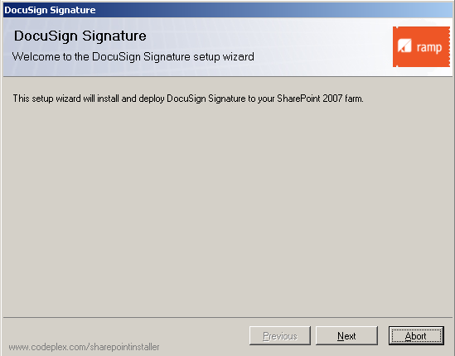

Step2:

To install this feature, initially it will check whether all services and basic requirements are installed in a system as shown below. Now click Next button.

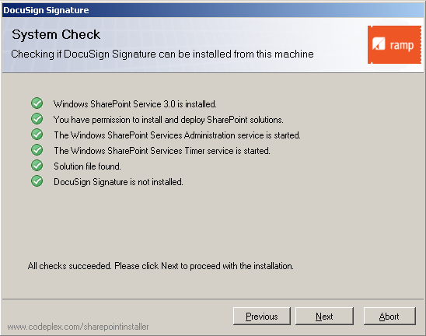

Step3:

Read the provided End-User License Agreement and place a check mark in the box provided for **“I accept the terms in the License Agreement”**. Click next

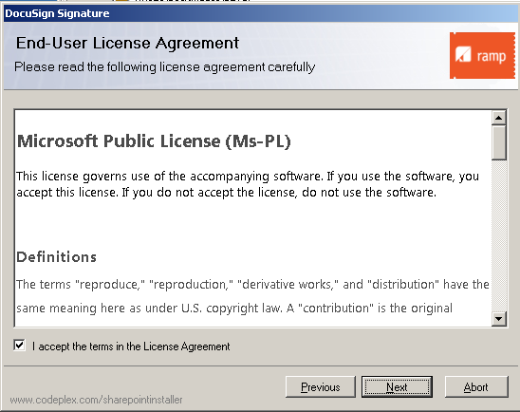

Step4:

It shows all the web applications created in the SharePoint server; select the SharePoint site where this feature is to be installed and then click next as shown below.

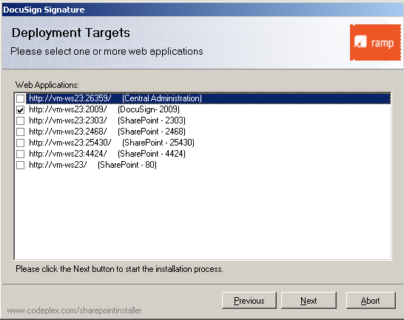

Step5:

Here the installation process is going on. Please wait until **“All the operations are successful”** displays.

Then click next.

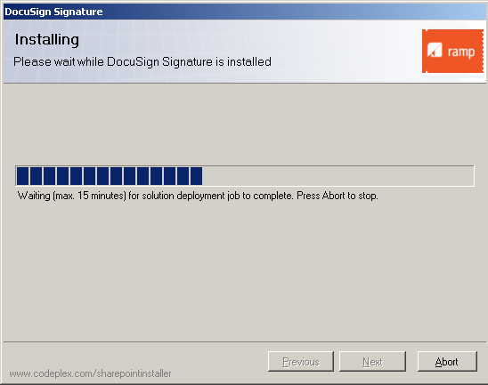

Step6:

After successful completion of installing the feature, you will get a message **“SOLUTION DEPLOYMENT”**. Click close

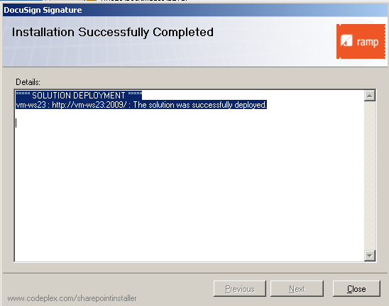

Steps to activate the feature in the SharePoint Site:

Step1:

Go to the site actions in the SharePoint site 🡪 click on site settings

Otherwise, use this link directly in your address bar <http://servername:portnumber/_layouts/settings.aspx>

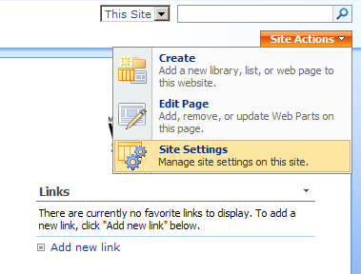

Step2:

Under the “**Site Collection Administration”** section, click on the “S**ite collection features**” as shown below

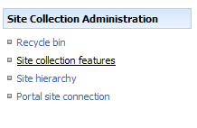

Step3:

Click on “**Activate**” button under the DocuSign Signature section, to activate the DocuSign Feature.



Step4:

After activating feature, go to the Document library you will find two options for signing the document and for sending document request to the user in the document item context menu as shown below.

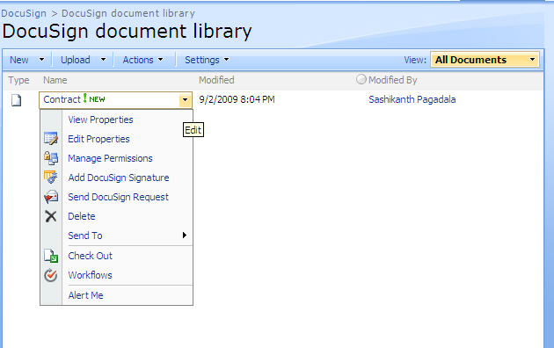

Step5:

Send DocuSign Request:

Steps to send request for the user to sign the document

1. Click on “**Send DocuSign Request**” where to send a request for SharePoint user to sign the document.
2. User will be prompted to provide a user alias. (SharePoint user from existing profiles).

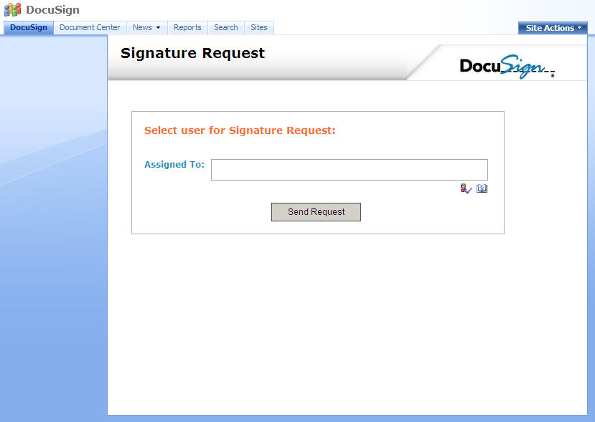

**Figure: 1** SharePoint People Picker field to select the user to send the signature request. Email will be sent to the emailed on the user’s profile.

1. Once the information (user is selected) is submitted, the user will receive an email notification with a link to the document in SharePoint and request to sign using secure DocuSign account as shown below.

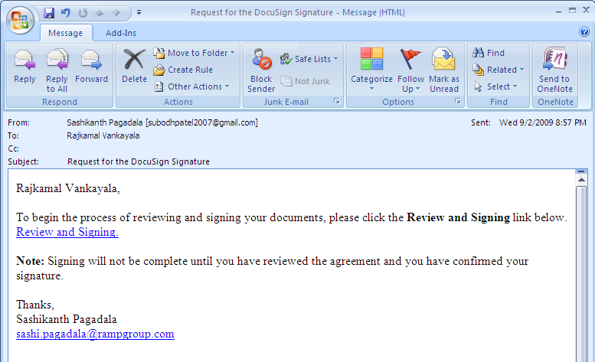

**Figure: 2**

1. To keep a track of latest signature requests submitted for a given document, the requested user name and date & time requested will be saved.
2. Clicking on the link in the email, user will be redirected to the DocuSign signature page in SharePoint site for signing.
3. Once logged in, the user is presented with the Conduct Business Electronically agreements and is able to modify their signature if needed as shown below.

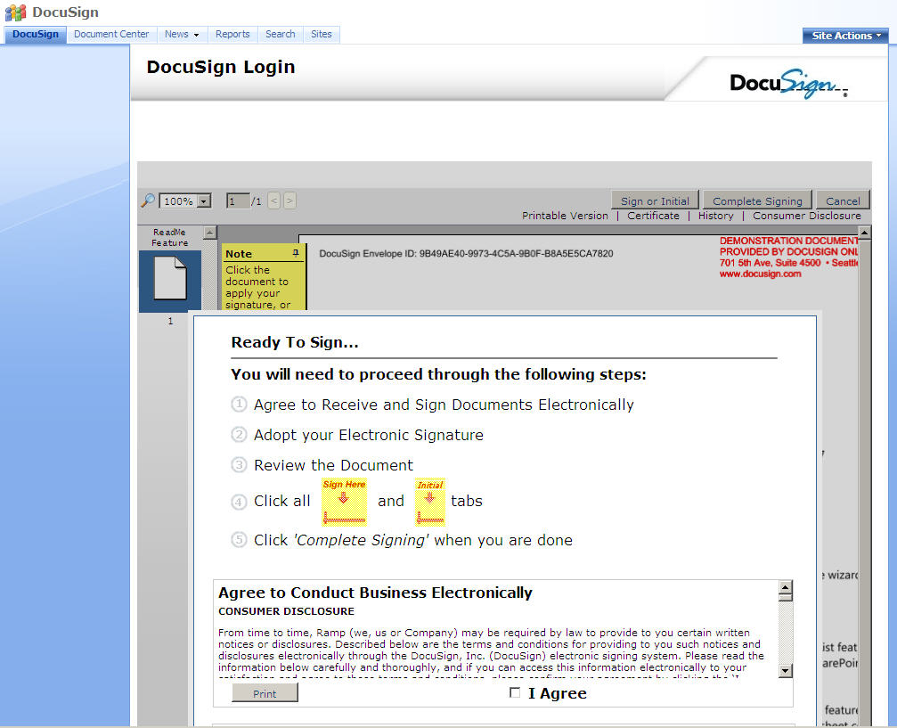

**Figure: 3**

1. The default status of an uploaded document is “**Pending**”.
2. User can then place the signature and Initials as needed in the document and click “***Complete Signing***”.
3. Once completed, the signed document will be saved back to the document library,
4. Version will be increased if enabled on the document library,
5. DocuSign feature can be restricted to file types (pdf only). If you try to add signature to a non-pdf file, you will get the error “***DocuSign supports pdf files only. Please upload a pdf files and try again***” as shown in **Figure: 4**.

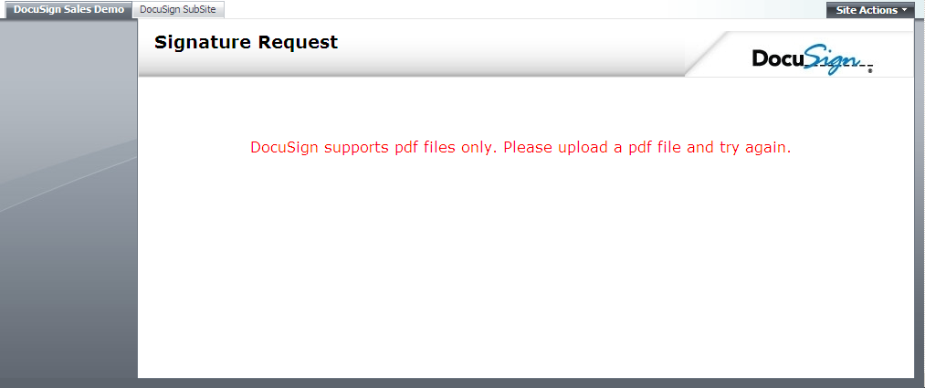

**Figure: 4**

1. DocuSign feature can be restricted to the checked in files only. If you try to send signature request or add the DocuSign signature, you will get the error “**The document you are trying to access is checked out. Please checkin the document for successful signing.**” as shown below

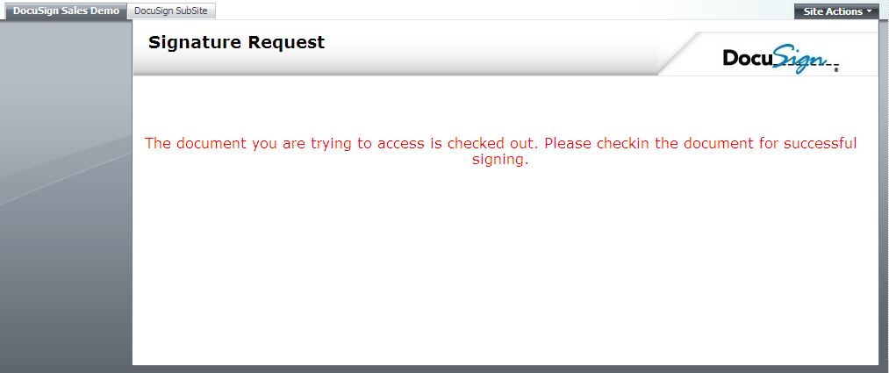

**Figure: 5**

Steps to add DocuSign Signature to PDF Documents:

1. Open the SharePoint Document Library where the to-be signed pdf document is uploaded.
2. When a document is uploaded, the status column for the document is by default set to “**Pending**”.
3. Select the document to open the SharePoint default item menu (context menu of **Name** Column of the document as shown in **Figure: 1**) and Click on ***Add DocuSign Signature.***

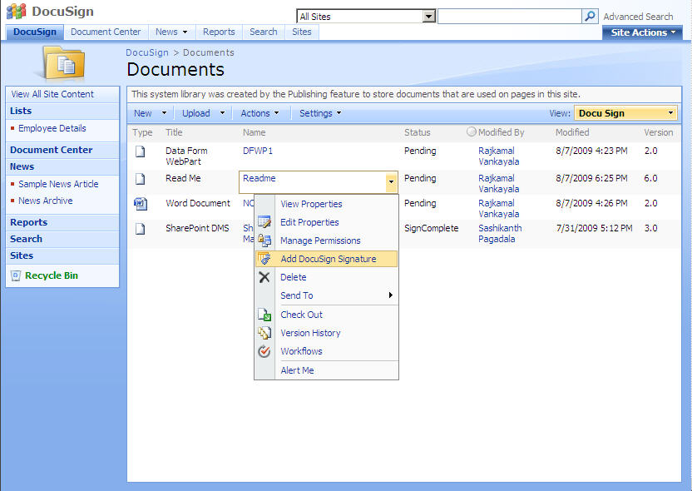 **Figure: 6**

1. User will be redirected to the DocuSign signature page as shown in **figure: 3**.
2. Status for the document will be updated in the “**status**” column. (For successful completion, you will find the status as “**Sign Complete**” and for the declined you will find the status as “**Decline**” as shown below.

For Sign Completed:

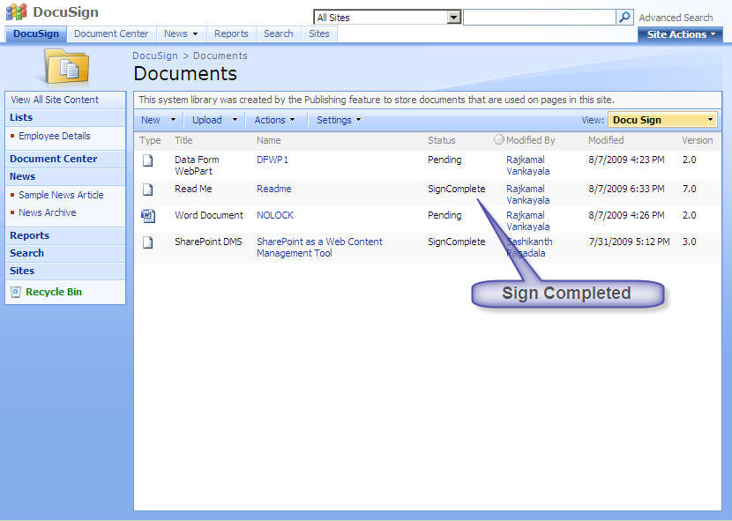

**Figure: 7**

For Decline:

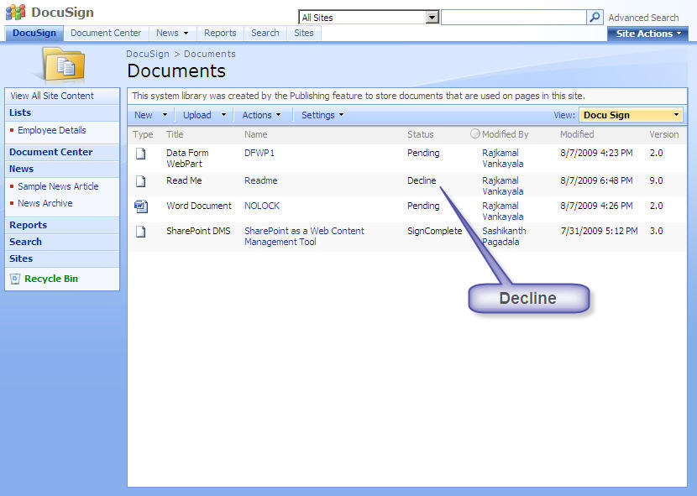

**Figure: 8**

Changes to be made in Web.Config file after activation of DocuSign feature:

* Provide the SMTP Server in **appsettings** tag for sending mails to the user as shown below.

<add key="smtpServer" value=" PleaseProvideYourSMTPServerHere" />

Problem:

If you are trying to send the DocuSign signature request for the document without changing the smtpserver in the Web.Config file, you will get the error “**Failure sending mail**” as shown below

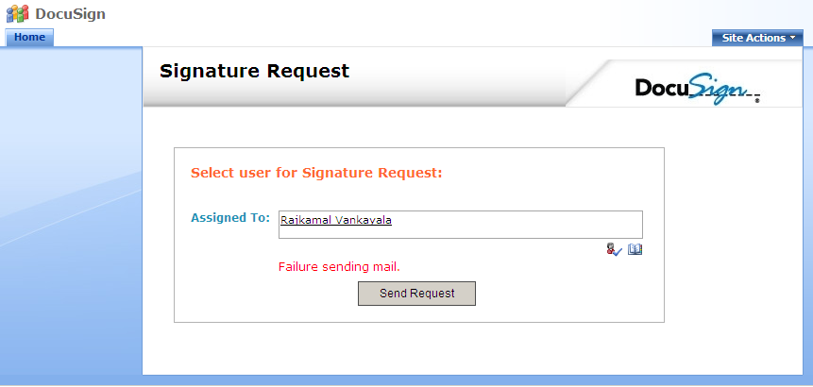

**Figure: 9**

* Provide the correct “**docuSignUserName**” and “**docuSignPassword**” value in **appsettings** tag to add the signature for document as shown below.

<add key="docuSignPassword" value="demo" />

<add key="docuSignUserName" value="demo@DocuSign.com” />

Problem:

If you are trying to add the DocuSign signature request in the document without changing the **docuSignUserName** and **docuSignPassword** in the Web.Config file, you will get the error “**Unable to process your request due to insufficient DocuSign credentials.Please contact your site administration**” as shown below

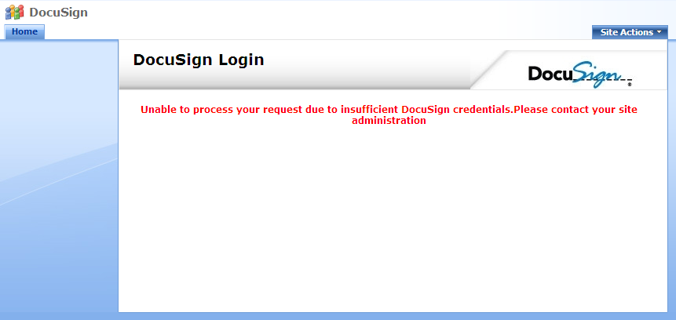

**Figure: 10**

Steps to uninstall the DocuSign feature:

* Deactivate the feature which is located in Site. (To deactivate, follow the same steps as we used for activating the feature) before uninstalling the feature.
* Then remove the feature by clicking on the **setup.exe file** and follow the wizard.